Guide to Adding a Supplier in the Ops Center
This document outlines all necessary fields and their descriptions for adding a supplier in the Ops Center. It covers Personal Details, Address Details, Identification Details, Vehicle Details, and Account Details to ensure all required data is captured efficiently.
1. Access Supplier Management
- Use your credentials to log in to the Ops Center dashboard.
- From the main menu, select the Users option.
- Under the Users section, choose Suppliers to manage or add new supplier details.

2. Add a Supplier
- Click on Add Supplier:
Click the Add Supplier button to open the supplier creation form.
- Fill in Personal Details:
  - First Name*: Enter the supplier’s first name.
  - Last Name*: Enter the supplier’s last name.
  - Mobile Number*: Input the supplier’s mobile number with the correct country code.
  - Phone Number*: Provide an additional contact number.
  - Email*: Enter the supplier’s email address.
  - Company Name*: Provide the name of the supplier's company.
  - Register*: Select whether the supplier is Registered or Non-Registered.
  - WhatsApp Mobile Number*: Add the WhatsApp contact number (with country code).
  - Office Mobile Number*: Provide the office phone number (with country code).
  - Working Hours (24 Hrs)*: Select Yes if the supplier works round the clock; otherwise, choose No.
  - Status*: Choose one of the following statuses:
    - Pending
    - In Review
    - Active
    - In-Active
  - Blocked User*: Select Yes if the supplier is blocked; otherwise, choose No.
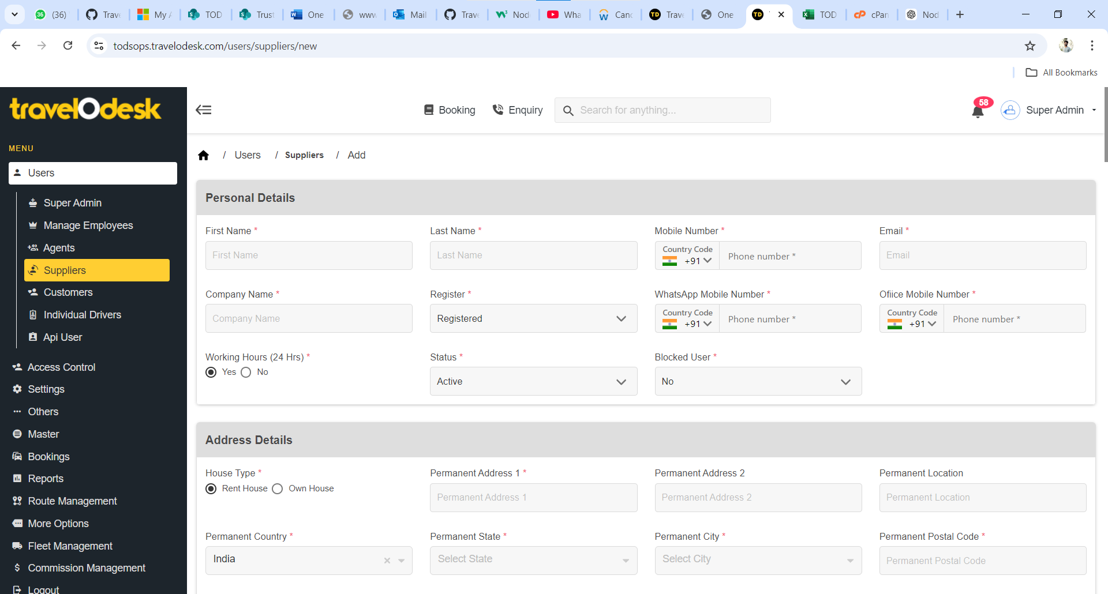
- Address Details:
  - Permanent Address:
    - House Type*: Choose Rent House or Own House.
    - Permanent Address 1*: Enter the first line of the permanent address.
    - Permanent Address 2: (Optional) Enter additional address details.
    - Permanent Location: Provide the location.
    - Permanent Country*: Default is India.
    - Permanent State*: Select the state.
    - Permanent City*: Select the city.
    - Permanent Postal Code*: Enter the postal code.
  - Present Address:
    - Check Present address same as Permanent if applicable.
    - House Type*: Choose Rent House or Own House.
    - Present Address 1*: Enter the first line of the present address.
    - Present Address 2: (Optional) Enter additional address details.
    - Present Location: Provide the location.
    - Present Country*: Default is India.
    - Present State*: Select the state.
    - Present City*: Select the city.
    - Present Postal Code*: Enter the postal code.
  - Office/Garage Address:
    - Check Office address same as Present if applicable.
    - Office/Garage Type*: Choose Rent Office/Garage or Own Office/Garage.
    - Office/Garage Address 1*: Enter the first line of the office/garage address.
    - Office/Garage Address 2: (Optional) Enter additional address details.
    - Office/Garage Location: Provide the location.
    - Office/Garage Country*: Default is India.
    - Office/Garage State*: Select the state.
    - Office/Garage City*: Select the city.
    - Office/Garage Postal Code*: Enter the postal code.
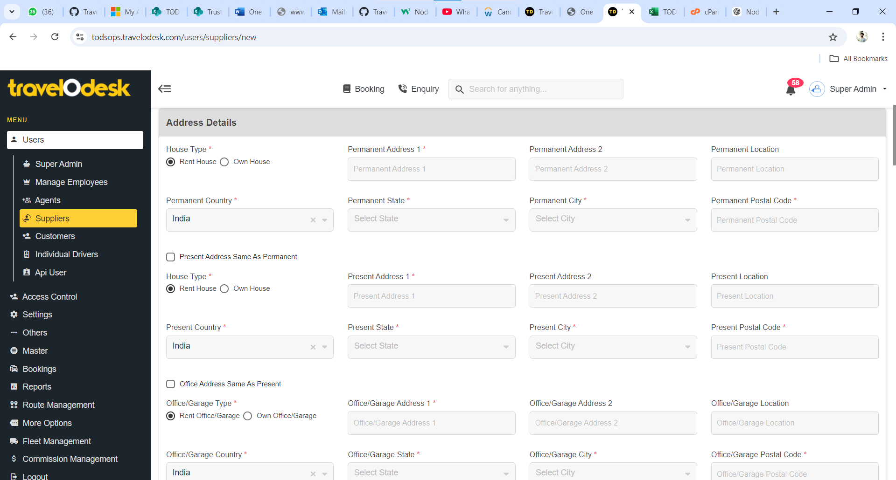
- Identification Details:
  - Aadhaar Number / Any Other Government ID*: Enter the identification number.
  - Aadhaar Card Image / Any Other Government ID Image*: Upload the identification image (Max size: 5 MB).
  - GST Number*: Provide the supplier's GST number.
  - GST Certificate Image*: Upload the GST certificate image (Max size: 5 MB).
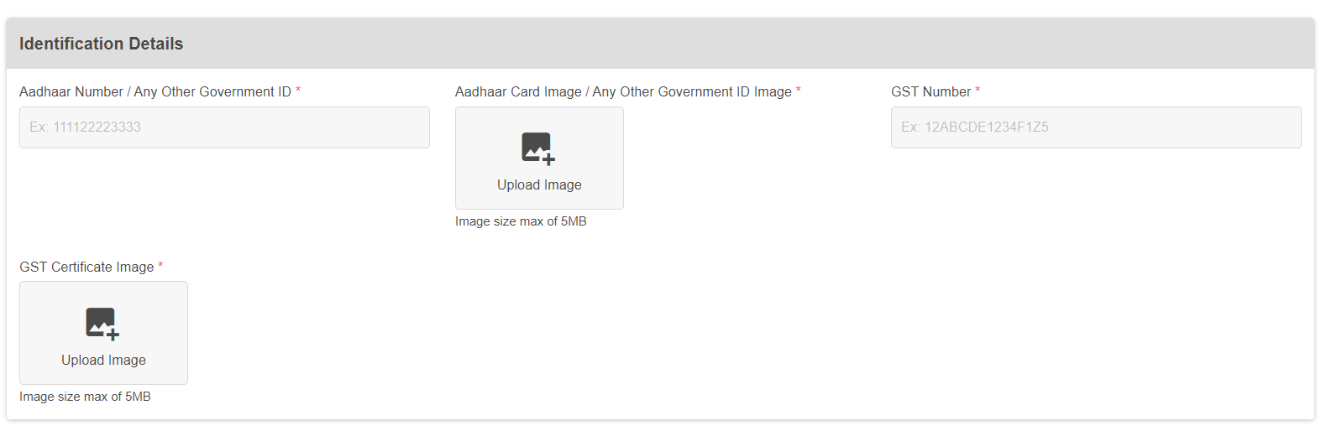
- Vehicle Details:
  - Owned Vehicles:
    - Number of Vehicles Owned*: Enter the number of vehicles owned by the supplier.
    - Types of Vehicle: Select one or more types from the following options:
      - Standard
      - People Carrier
      - Premium
      - Large People Carrier
      - Hatchback
      - Minibus
      - Super Luxury
      - Premium Minibus
      - Standard Bus
      - Luxury Minibus
      - Deluxe Bus
  - Attached Vehicles:
    - Number of Vehicles Attached*: Enter the number of attached vehicles.
    - Types of Vehicle: Select the types as listed above.
- Account Details:
  - Bank Details:
    - Account Number: Enter the account number.
    - Account Holder Name: Provide the name of the account holder.
    - Account Type: Choose from Savings or Current.
    - Bank Name: Enter the name of the bank.
    - Branch: Provide the branch name.
    - IFSC Code: Enter the IFSC code.
  - PAN Details:
    - Pan Number: Provide the PAN number.
    - PAN Card Image: Upload the PAN card image (Max size: 5 MB).
  - UPI Details:
    - UPI Name*: Select one of the following options:
      - Google Pay
      - Phone Pay
      - Amazon Pay
      - Paytm
      - Bank Pay
    - UPI ID: Enter the UPI ID.
    - UPI User Name: Provide the name associated with the UPI.
    - QR Code Image: Upload the QR code image (Max size: 5 MB).
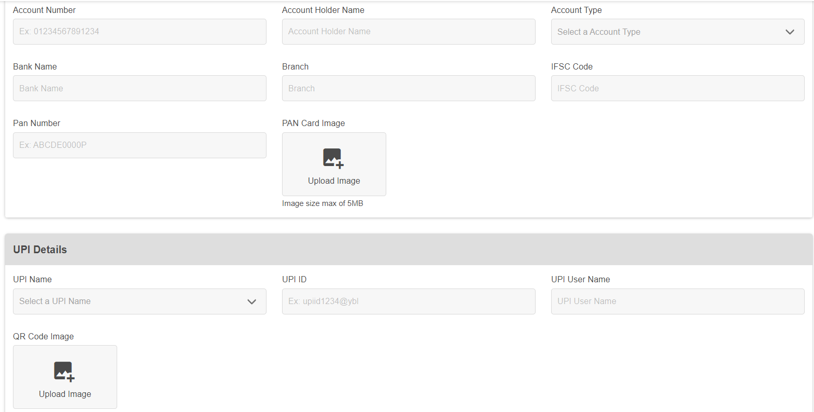
- Submit the Form:
  - Review all the entered details.
  - Click on Submit to save the supplier’s information.

